Emergency Maps

Choose a map type

Fire escape

Tornado shelter area map

Tornado shelter? (This may be a separate thing)

Emergency Maps

Choose a map type

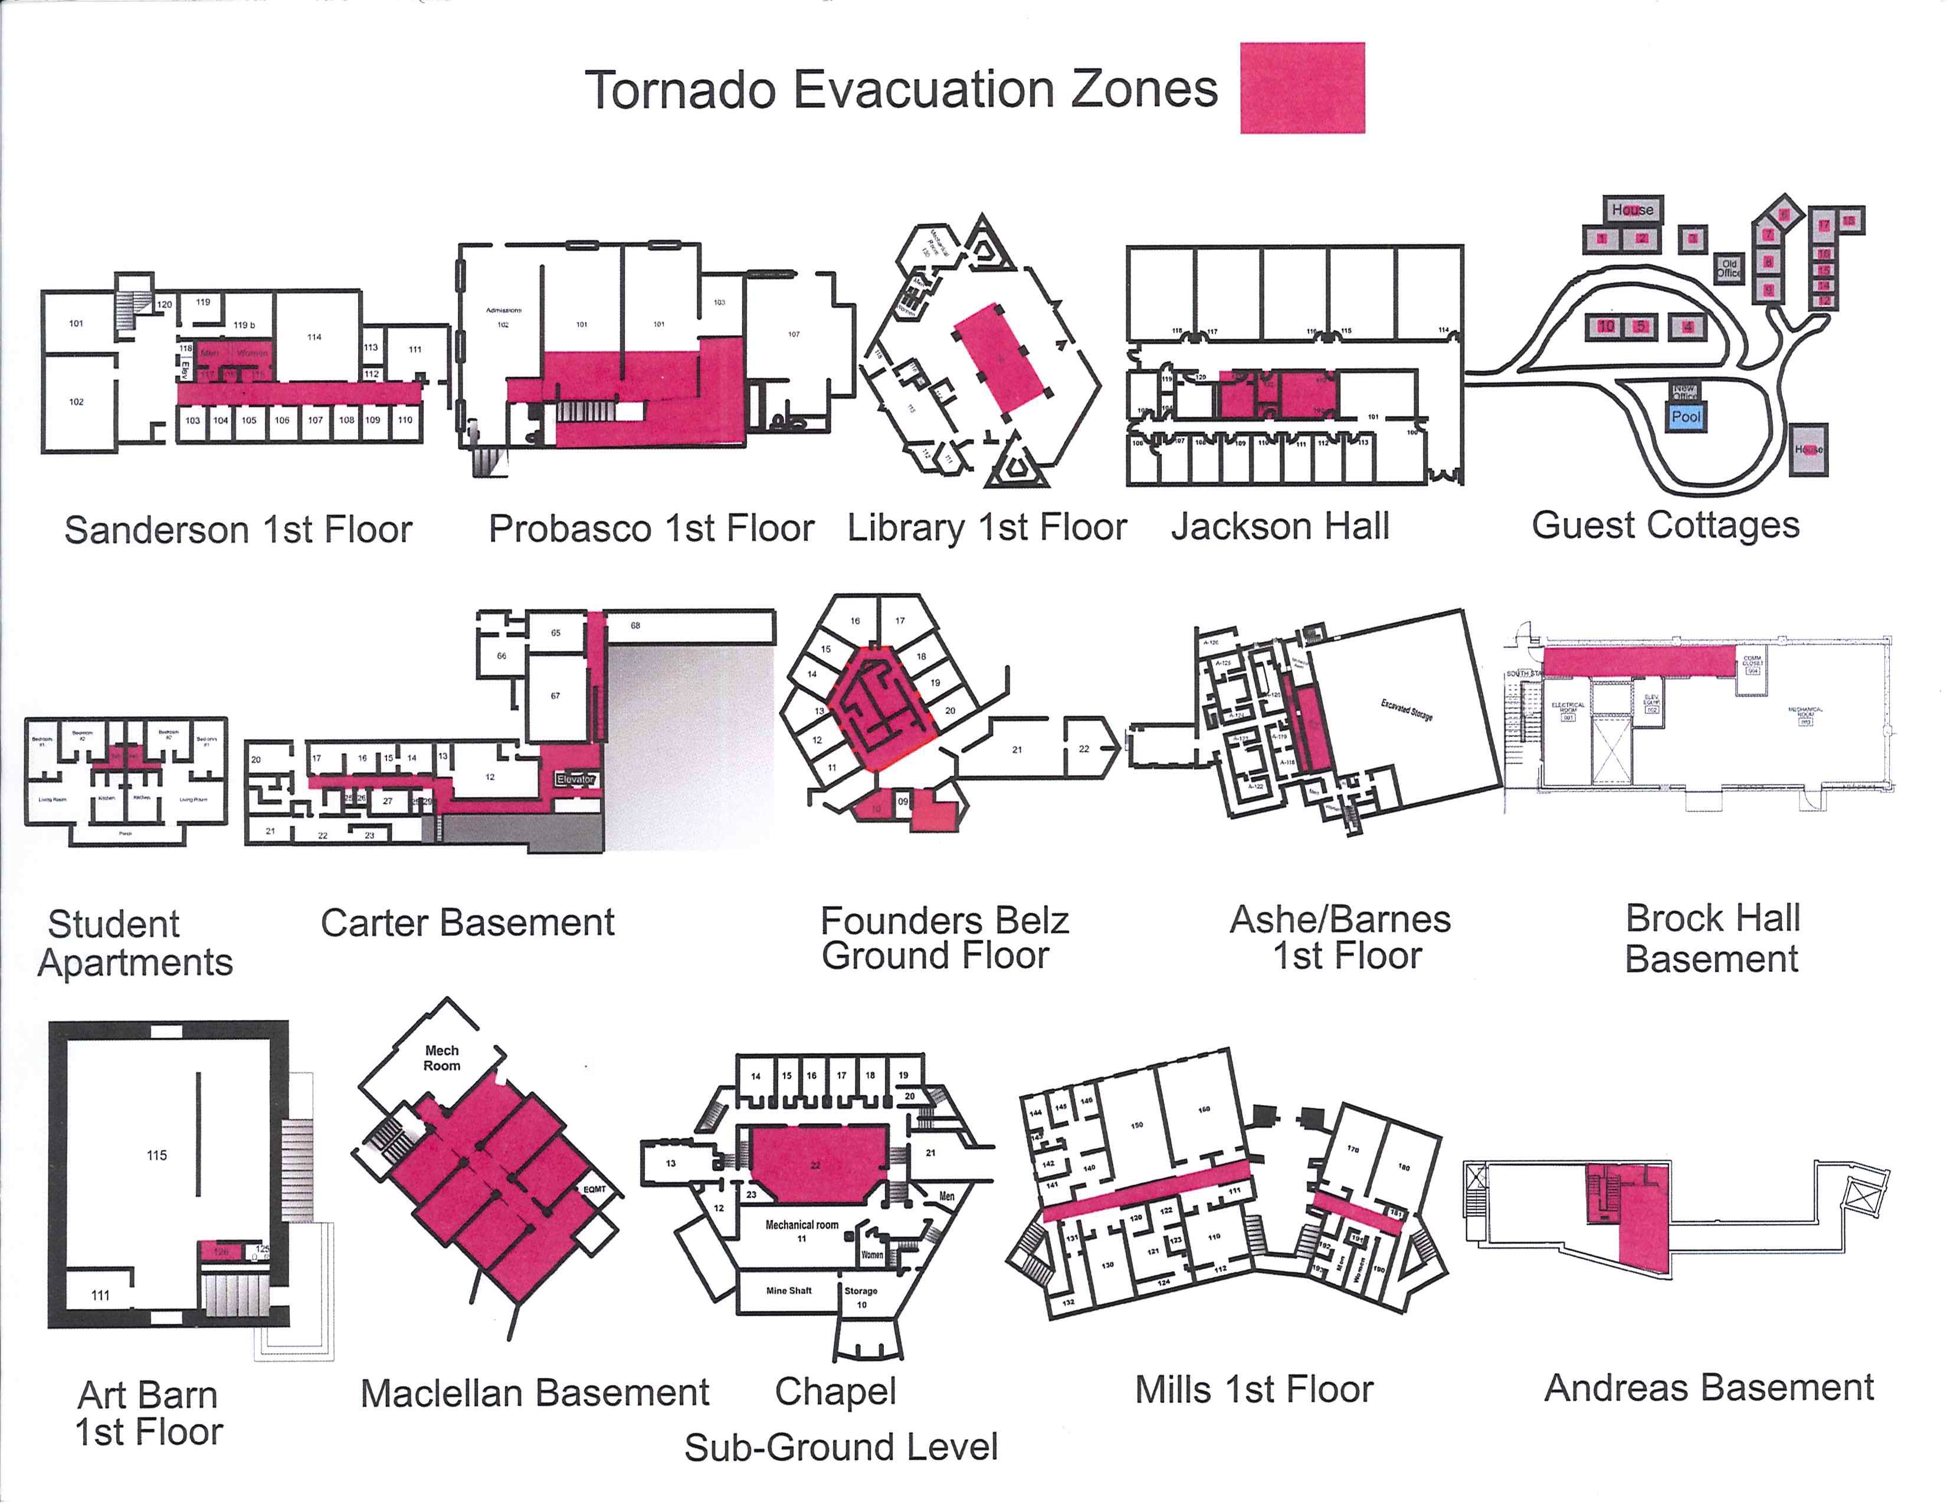

Emergency Maps

Tornado shelter